Calculating Zone-based Cancer Rates

This process describes how to calculate zoned-based cancer incidence rates. It assumes that you have access to individual-level cancer data geocoded to census tracts in SEER*Stat and that these data are linked with the tract-level population denominators needed for calculating age-adjusted rates.
- For SEER registries, a database with incidence data linked to census tract attributes is available and can be used for this process. The currently available database is: Incidence - SEER Research Plus Limited-Field Specialized Data (Cancer Reporting Zone Analyses), 21 Registries (excl AK and IL), Nov 2024 Sub (2006-2022) <Vintage 2023 Pops by Tract 2010 Geographies>. This database will be referred to as the “Incidence - SEER Specialized Limited-Field Database” throughout this document. If you have the approval of your registry’s PI, you may request access by contacting Mandi Yu (NCI) [mandi.yu@nih.gov], Steve Scoppa (IMS) [scoppas@imsweb.com], and Diane Ng (Westat) [dianeng@westat.com].
- For non-SEER registries, you can create a local SEER*Stat database using census tract 2010 geography linked to census tract attributes. For more information, see the topic “Resources for Calculating Rates for Small Areas and by ABSMs” under GIS Resources on the NAACCR website.

We also assume you have access to SAS. This process is designed to produce SEER*Stat matrix files that can be used to generate the cancer rate tables needed for the web-based tool for cancer reporting by zones. If desired, Westat can assist with this processing once any necessary data usage agreements are in place.

For this process, we assume files reside in a Windows folder called C:\Work\ZoneRateCalcs. This folder can be located anywhere, including on a network drive. The SEER*Stat output files contain tables with small cells that will ultimately be suppressed based on your desired suppression rules. Thus, access to the folder where the SEER*Stat output files are kept should be limited to authorized users.

In this process, we refer to variable parameters using square brackets. For example, [StAbbr] refers to the state abbreviation for your registry.

If you do not have access to the Incidence - SEER Specialized Limited-Field Database specified above and/or your zone definitions are not yet available in the SEER-provided Census Tract Attributes file, you may still be able to calculate zone-based cancer incidence rates. Please see the Appendix for additional steps and requirements.

- Define and run a SEER*Stat rate session to calculate zoned-based cancer rates
  - Create a SEER*Stat rate session file for zone-level rates named “[RunNum]zone_RateCalcs.si”. Parameters:
    - Data tab: select the SEER*Stat database with tract IDs for cancer cases, or the Incidence - SEER Specialized Limited-Field Database if using
    - Create a user-defined variable based on the variable Cancer Reporting Zone in the database.
      - The Cancer Reporting Zone variable is under the section ‘Tract Attributes Geography and Year’
      - Select the Cancer Reporting Zone values applicable to your state/catchment area. Name the new user-defined variable “ZoneID_[StAbbr]”.
      - Note: the Cancer Reporting Zone values in the SEER*Stat database for your state/catchment area should match the ZoneIDFull values in the “ZonedTracts_[RunNum]_final.xlsx” file Westat provided to your registry as part of the final cancer reporting zone materials. If the values do not match the ZoneIDFull values or if the “ZonedTracts_[RunNum]_final.xlsx” file your registry has does not include a ZoneIDFull variable, please contact Westat for an updated file.
    - Import other user variables (.fmx files included with the distribution folder) and modify as needed:
    - LatestYears_1_5_10: defines the groups of years you wish to generate rates for. The sample has 1-year, 5-year, and 10-year groups ending in 2015.
      - Note: if modifying the years defined in the variable, keep the name of the variable as “LatestYears_1_5_10”.
    - USCS_Sites: the cancer sites to be included. The sample includes the cancer sites reported by USCS.
    - RaceOriginRecode_wAllRaceEth (variable name: Race and origin recode with AllRaceEth): race and ethnic origin groups. The sample includes non-Hispanic White, non-Hispanic Black, non-Hispanic API, non-Hispanic AIAN, non-Hispanic unknown race, Hispanic, and a combined grouping of all races and ethnic origins.
    - CTCertainty_ReportingZone_Recode (variable name: Census Tr Certainty 2010 for Reporting Zone Analysis recode): categorization of cases into two categories – “High certainty (1,2,6) or low certainty but tract not required for zone” and “All values”.
      - For registries creating their own database and not using the Incidence - SEER Specialized Limited-Field Database, you will need to create your own version of this variable specific to your database if you would like to limit your cases to those with high census tract certainty and/or with low certainty but the tract is not required for assigning Reporting Zone (see the Selection tab specifications below for more information). To do this:
        - Create a merged variable called ‘Census Tr Certainty 2010 for Reporting Zone Analysis recode’.
        - Add a grouping called ‘High certainty (1,2,6) or low certainty but tract not required for zone’ with the following criteria:
Geographic Locations.Census Tr Certainty 2010} = 'Based on complete and valid street address of residence','Based on residence ZIP+4','Based on res city/ZIP where city/ZIP has only one cen tract'
OR {Geographic Locations.Census Tract Required for Cancer Reporting Zone} = ‘Can assign zone based on county'
    - Statistics tab: age-adjusted rates, show standard errors and CIs
    - Selection tab: needed years, registry/state of interest
      - In some cases, you may want to limit cases to those with high census tract certainty or with low certainty but the tract is not required for assigning Reporting Zone to ensure that cases are being assigned to the correct zone. For cases with low census tract certainty or where county alone is not enough to assign a case to a zone, it is possible that the case can be assigned to the wrong zone based on being geocoded to the wrong census tract.
        - If most cases have high census tract certainty and for calculating zone-level rates across a whole state or catchment area and for the purpose of general users seeing how rates vary across the state, it may not be as necessary to limit the cases. In contrast, if many cases have low census tract certainty or if your registry or researchers are focusing on urban areas where the zones are smaller and geocoding errors might be more significant, it might make sense to limit the cases. See below for a table of considerations and suggestions.
Consideration | Possible effect
Percent of poor geocodes | If there is a high percentage of cases with low census tract certainty, then these cases may be assigned to the incorrect zone. Before deciding on whether to include or not include cases with low census tract certainty, you may want to review the geocoding for the cases to be included in the analysis and whether any improvements can be made to the geocoding (e.g., fix any potential typos in an address; verify that the address recorded is correct and complete).
Scale of the analysis | If the analysis is focused on a specific area (e.g., a single county), then the analysis is more reliant on the case being in the proper zone. For this scenario, we would recommend only including the cases with high census tract certainty or with low certainty but tract not required for assigning the zone.
Urban versus rural | Lower quality geocodes (e.g., geocoded based on a ZIP code centroid) may be more likely to assign a case to the incorrect zone in an urban area but may be more likely to assign a case to the correct zone in a rural area.

        - If you would like to limit your cases, add to the selection under the ‘Other (Case Files)’ section using the ‘Census Tr Certainty 2010 for Reporting Zone Analysis recode’ variable. Select one or both groupings “High certainty (1,2,6)” and “Low certainty but tract not required for zone” based on what cases you would like to include.
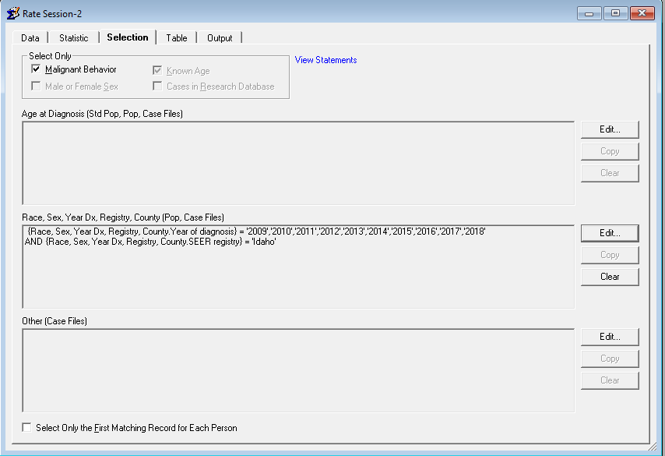
    - Table tab:
      - Page: ZoneID_[StAbbr]
      - Row: Sex, LatestYears_1_5_10, USCS sites
      - Column: Race and Origin with AllRaceEth
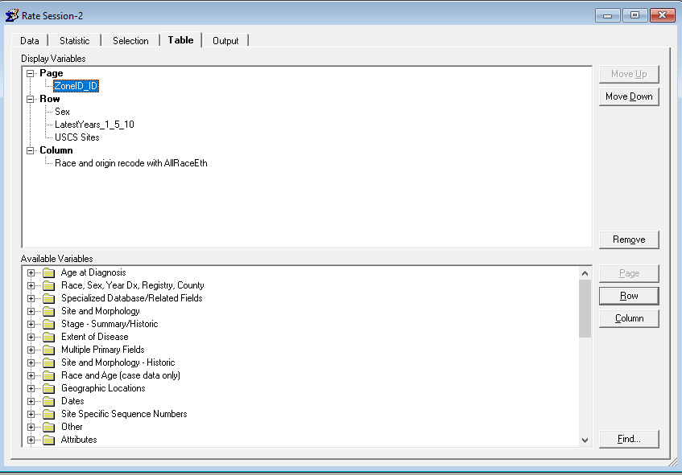
    - Output tab: 3 decimal places, don’t hide statistics for small cells. (Note: this enables a summary of cell suppression in to be generated when processing the results. If desired, suppression rules can be implemented here.)
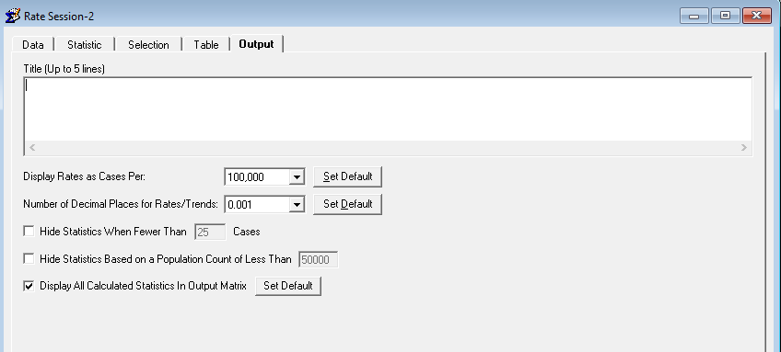
  - Run the rate session and save the resulting matrix file.
  - Export the matrix using the Export Results as Text File dialog with the “Labels Enclosed in Quotes” option selected. The program that builds the tables for the web tool assumes the filename will be “[RunNum]zone_RateCalcs.txt”. Here is a screenshot of the Export dialog:
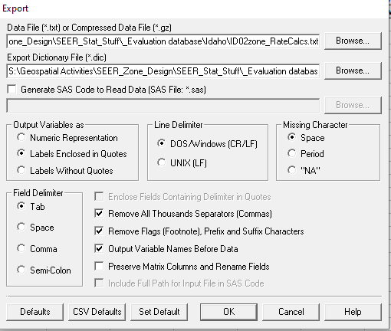
- If desired, define and run a SEER*Stat rate session to calculate the same cancer rates for the state as a whole. These state-level rates are needed for the web tool.
  - Copy the zone-level rate session and remove the zone field in the Tables tab.
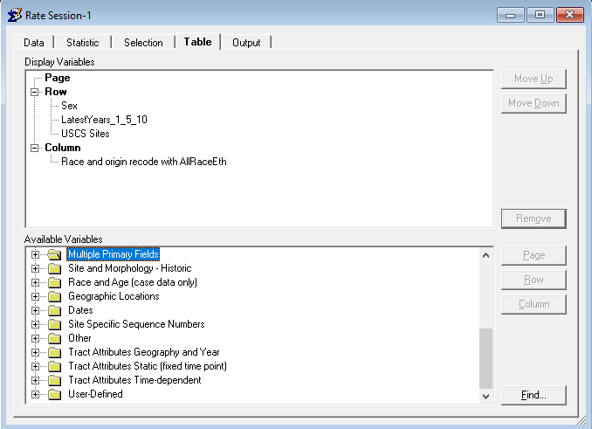
  - Run the rate session and save the resulting matrix file
  - Export the matrix using the Export Results as Text File dialog with the “Labels Enclosed in Quotes” option selected. The program that builds the tables for the web tool assumes the filename will be “[StAbbr]state_RateCalcs.txt”.
- If desired, define and run a SEER*Stat rate session to calculate the same cancer rates by county. These county-level rates are not needed for the web tool, but can be used to add county-level rates as an option.
  - Create a user-defined variable based on the variable State-county in the database.
      - The State-county variable is under the section ‘Race, Sex, Year Dx, Registry, County’
      - Edit the variable:
        - Keep only the groupings associated with your state/registry.
        - In addition, delete the overall state grouping (e.g., Delaware, California) from the ‘Groupings’ section, as well as the unknown county grouping (if applicable).
        - Name the new user-defined variable “County_[StAbbr]”.
  - Copy the zone-level rate session and remove the zone field in the Tables tab.
  - Add the County_[StAbbr] variable under the Page section in the Table tab.
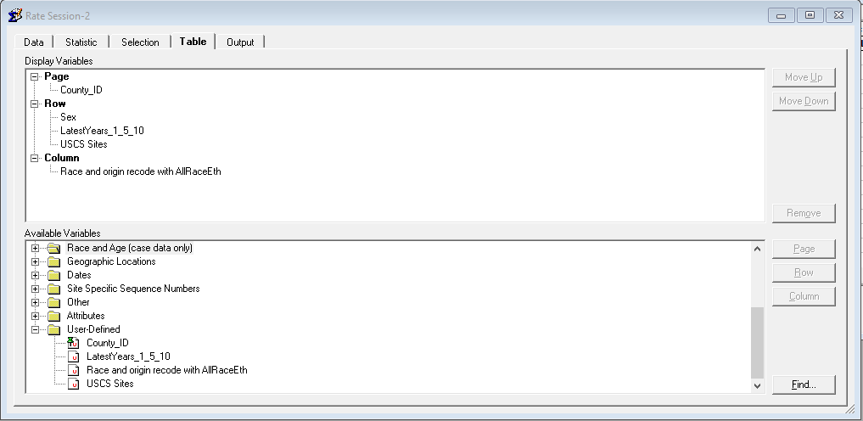
  - Run the rate session and save the resulting matrix file
  - Export the matrix using the Export Results as Text File dialog with the “Labels Enclosed in Quotes” option selected. The program that builds the tables for the web tool assumes the filename will be “[StAbbr]county_RateCalcs.txt”.

Appendix

These procedures are to be used by registries whose zone definitions have not yet been included in either the Incidence - SEER Specialized Limited-Field Database (SEER registries) or in the SEER Census Tract Attributes file (non-SEER registries) but whose definitions have been finalized and provided by Westat. The procedures outline how to create a user-defined zone variable to be used in a local SEER*Stat database with census tract 2010 geography data. If following these procedures, do these steps first before continuing with the steps above.

- Create a copy of the ZoneRateCalcs distribution folder in the desired location (we assume this is at “C:\Work\ZoneRateCalcs” for this process). Copy the final zoned tracts and zone list Excel files provided with the zone design results (“ZonedTracts_[RunNum]_final.xlsx” and “ZoneList_[RunNum]_final.xlsx”) to this folder.
- In SEER*Stat, generate a user-variable export file for all of the tracts in the state:
  - In a rate session, select the incidence database with tract geocodes
  - Open the Dictionary by clicking the dictionary icon:
  - Select the tract field for the SEER*Stat database (possibly named something like “State-County-Census Tract 1990/2000/2010 Recode”) and click “Create” to create a user variable based on this field
  - Change the name to Tracts_[StAbbr].
  - Clear all of the entries in the Grouping window by clicking in the window, typing Ctrl-A to select all, and then clicking Delete.
  - In the Values window, select all of the tracts for the state (click on the first tract for the state, then Shift-click on the last. You may need to know the state FIPS code for your state to identify the relevant tracts.
  - Click Add…
  - Select the “Added as separate groupings (one for each value)” and be sure the “Use underlying data values instead of names” option is not checked. Click OK.
  - Click OK to save this as a user variable and return to the Dictionary window
  - Click Export in the Dictionary window
  - Use “Browse…” to navigate to the “C:\Work\ZoneRateCalcs” folder and name the file “Tracts_[StAbbr].fmx”
  - Select the “Tracts_[StAbbr]” variable and click OK to create the file
  - Click “Close” to close the Dictionary window. Exit SEER*Stat.
- Run the 50_GenSEERStatVar_public SAS program to create a SEER*Stat user variable that defines each zone as a set of tracts
  - Set the %let parameters at the beginning of the code to specify the state abbreviation, run number, and data path if different from “C:\Work\ZoneRateCalcs”
  - Investigate any warning messages generated by the program as these usually mean something is not working as expected
  - The program creates a SEER*Stat “fmx” file to define a user variable called “ZoneID_[StAbbr]”

